📘 MongoDB Basics – Practical Assignment
Dataset:
Create a database named schoolDB and a collection named students. Insert the few sample documents:
It should have fields like id, name, age, grade, subjects (m enter multiple subjects), city.
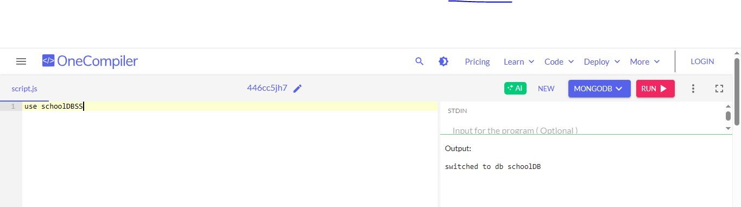
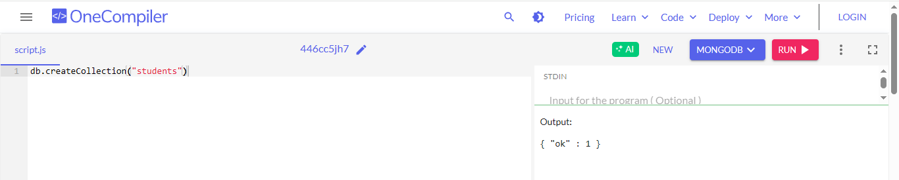
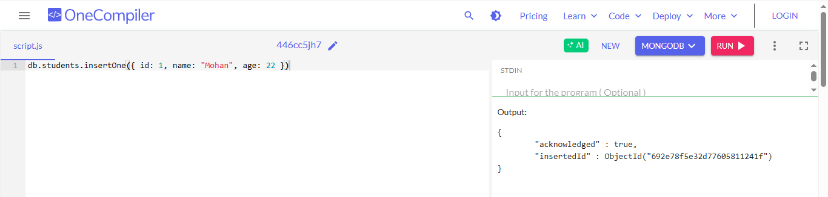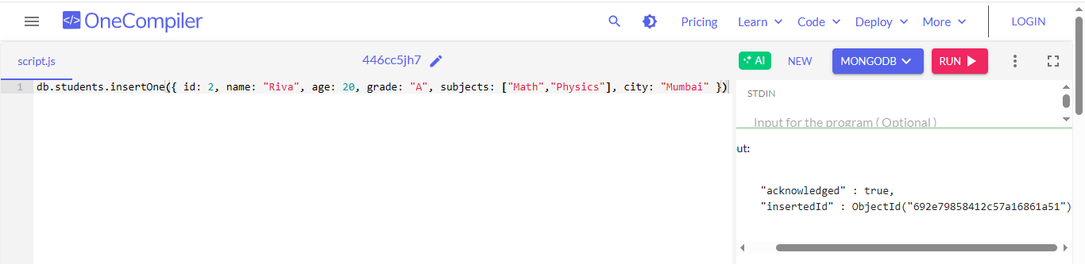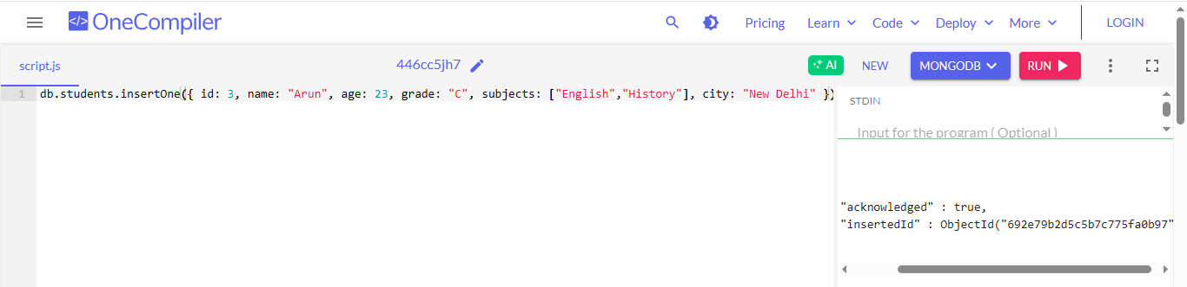
🔹 Assignment Questions
Q1. Insert Operations
- Insert a new student: Amit, age 24, grade A, subjects ["History", "English"], city "Calcutta"

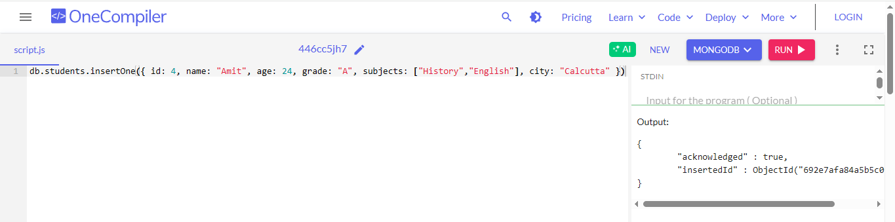
Q2. Find Queries
- Find all students who live in "New Delhi".
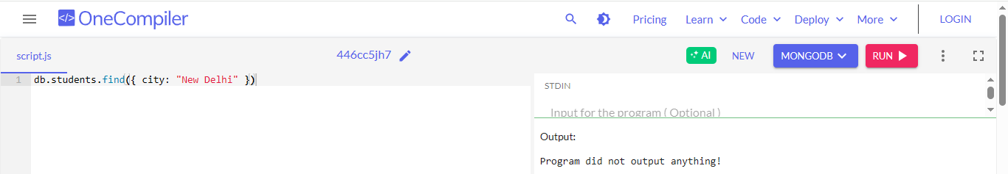
- Find all students with grade "A".
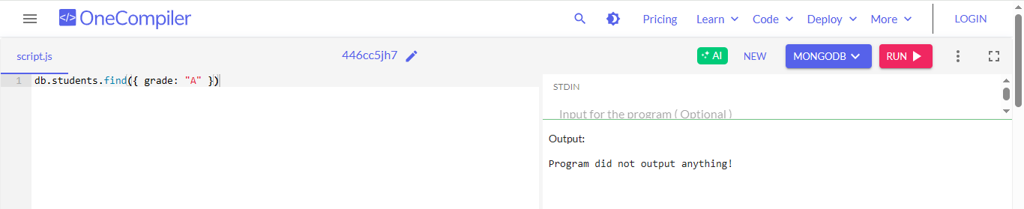
- Find all students who study "Math".
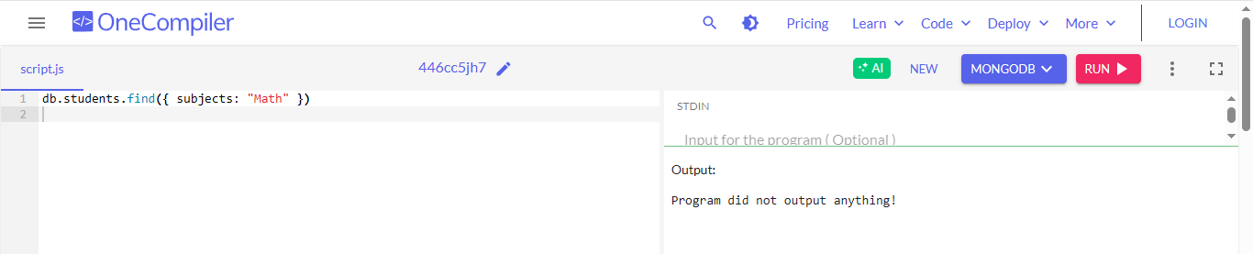
- Find students older than 21.
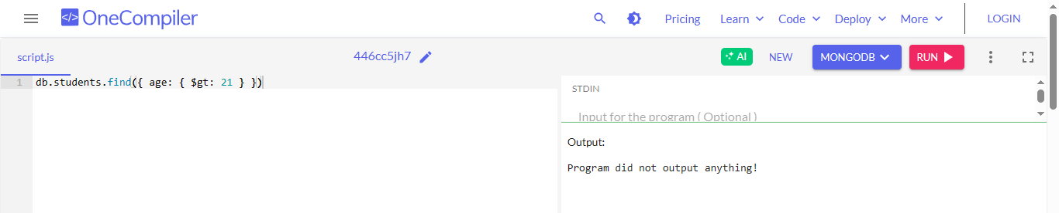
Q3. Projection
- Show only name and city of all students.
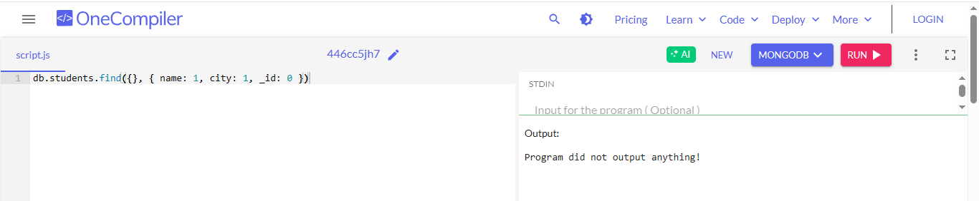
Q4. Update
- Update Mohan’s grade to "A".
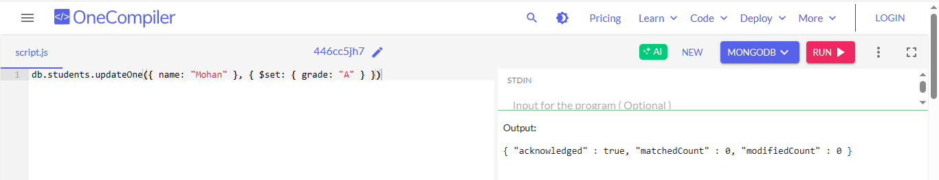
- Add "Computer Science" to Riva’s subjects.
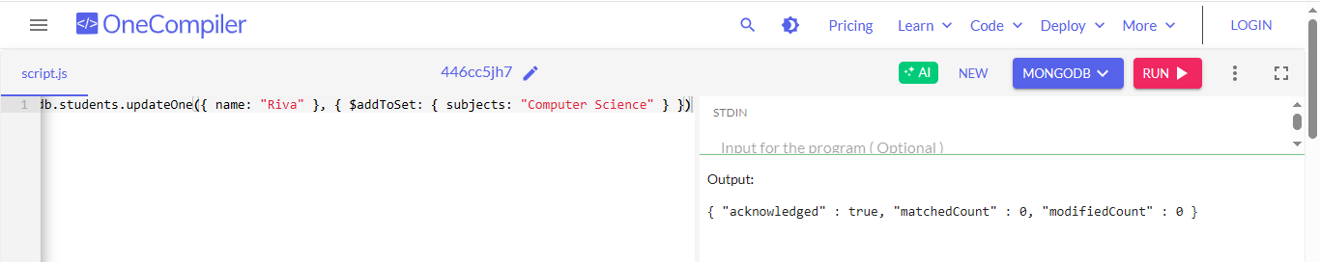
Q5. Delete
- Delete the student whose name is "Arun".
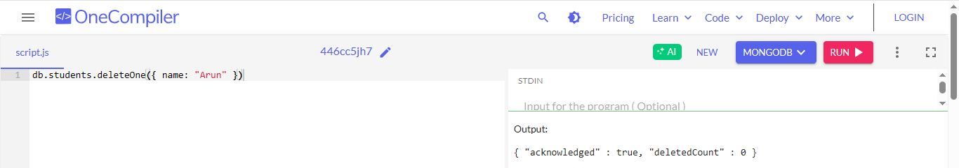
Q6. Sorting & Limiting
- Display all students sorted by age in descending order.
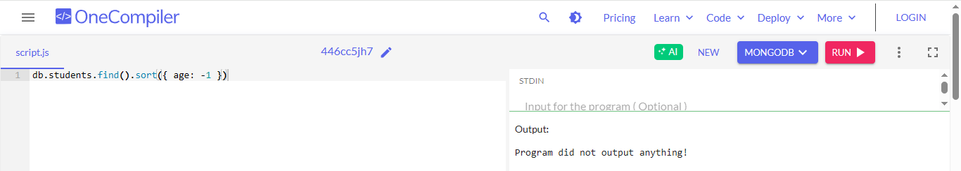
- Show the youngest student.
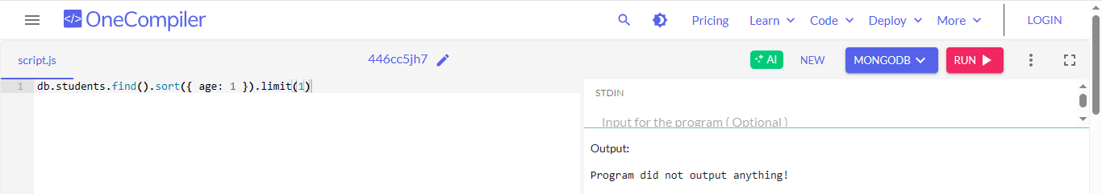
Q7. Aggregation
- Count how many students are in each city.
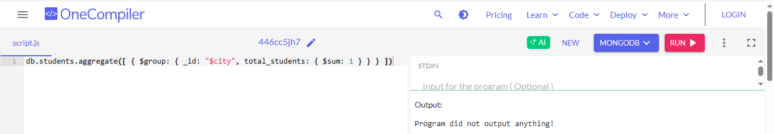
- Find the average age of students with grade "A".
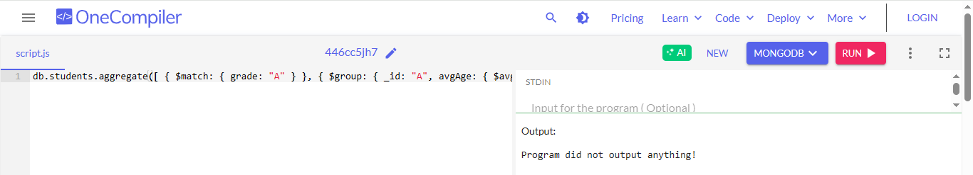

Part 1: Prepare the Virtual Machine
Step 1.1: Install VirtualBox
1. Download from: https://www.virtualbox.org/wiki/Downloads
2. Install VirtualBox like any normal Windows application.
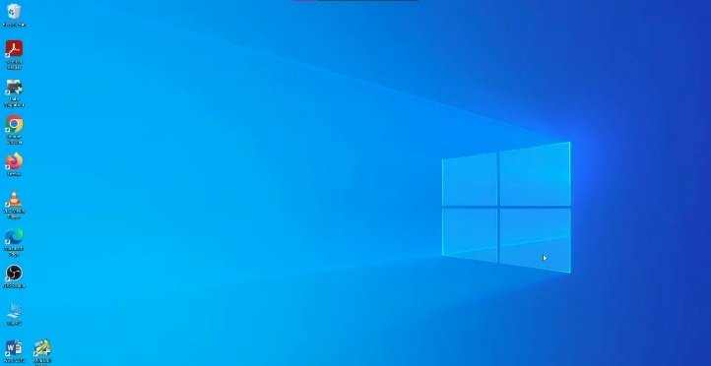
Step 1.2: Download Ubuntu ISO
Download the `.iso` file from https://ubuntu.com/download/desktop
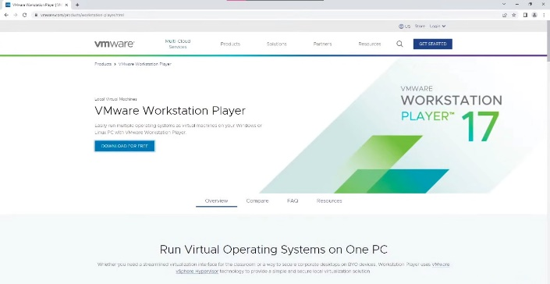
Step 1.3: Create the Virtual Machine
- Open VirtualBox → New
- Name: HadoopLab
- Type: Linux
- Version: Ubuntu (64-bit)
- Memory: 4096 MB
- Hard Disk: Create VDI (50 GB dynamically allocated)
- Start the VM and attach the downloaded Ubuntu ISO

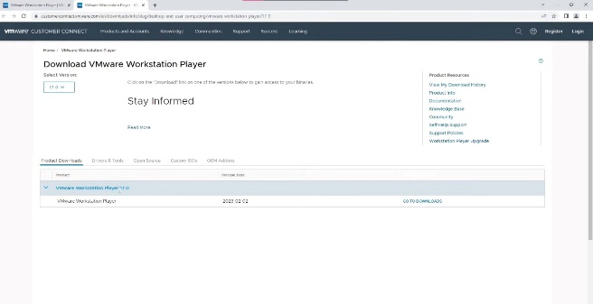
Step 1.4: Install Ubuntu Inside the VM
Follow on-screen instructions to complete the Ubuntu installation and set up username/password.

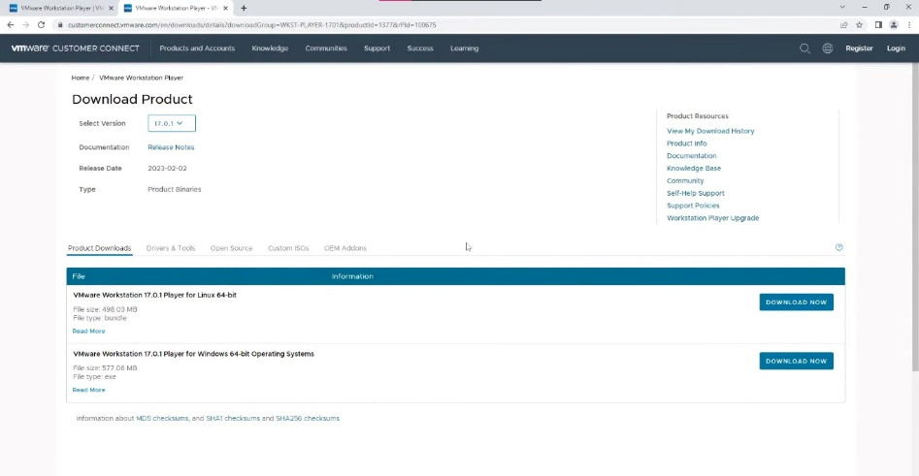

Part 2: Improve Usability of VM
Step 2.1: Enable Copy-Paste Support
- In VirtualBox (VM powered off):
- - Go to Settings → General → Advanced
- - Set Shared Clipboard to Bidirectional
- - Set Drag'n'Drop to Bidirectional
- Start the VM
- From the menu: Devices → Insert Guest Additions CD Image
- In terminal, install required headers:
- sudo apt update
- sudo apt install build-essential dkms linux-headers-$(uname -r) -y
- Mount and run Guest Additions:
- cd /media/$USER/VBox_GAs_*
- sudo ./VBoxLinuxAdditions.run
- Reboot: sudo reboot

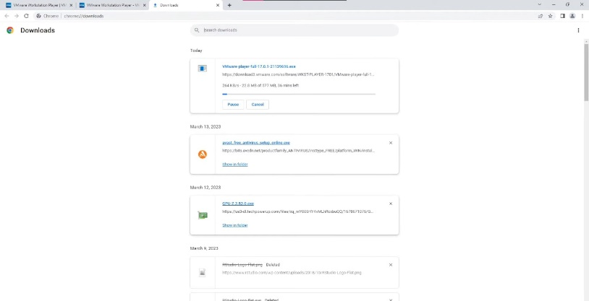
Part 3: Install Java (JDK)
Step 3.1: Install Java
sudo apt update
sudo apt install openjdk-11-jdk -y
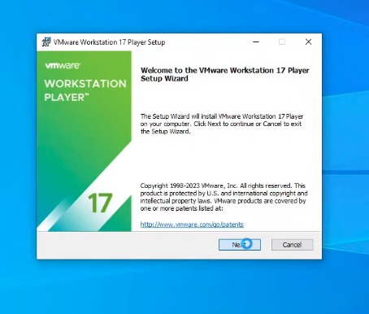

Step 3.2: Verify Installation
java -version
Expected output:
openjdk version "11.x.x"
Part 4: Install Hadoop
Step 4.1: Install Prerequisites
sudo apt install ssh rsync curl -y
Step 4.2: Download Hadoop
cd ~
curl -O https://downloads.apache.org/hadoop/common/hadoop-3.3.6/hadoop-3.3.6.tar.gz

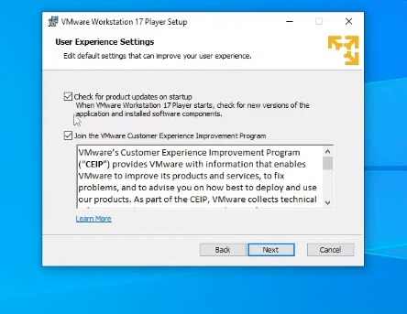
Step 4.3: Extract and Rename Hadoop Folder
tar -xzf hadoop-3.3.6.tar.gz
mv hadoop-3.3.6 hadoop

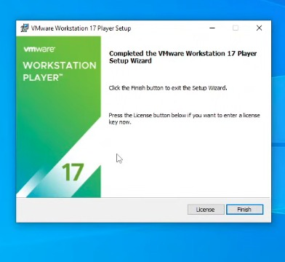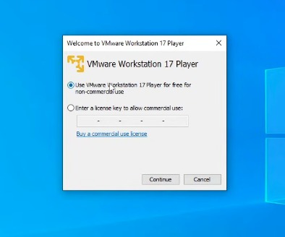

Lab 1: Introduction to HDFS Commands
Objective
To understand and perform basic Hadoop Distributed File System (HDFS) commands using the Cloudera environment and learn how to interact with HDFS for storing, retrieving, and managing files.

Tools / Components Used
- Cloudera Virtual Machine
- HDFS Shell
- Terminal

Introduction
Hadoop Distributed File System (HDFS) is a distributed storage system designed to run on commodity hardware. It provides:
- High fault tolerance
- Scalability
- Ability to store very large datasets
- Automatic replication of data across multiple nodes
In this lab, we explore the most commonly used HDFS commands such as listing directories, copying files, creating files, and deleting files.

Step-by-Step Commands with Output Explanation

1. Check HDFS Status
Command:
hdfs dfsadmin -report
Usage: Shows information about the HDFS cluster including total capacity, used space, number of datanodes, etc.
Expected Output:
A detailed report such as:
- Configured capacity
- DFS used / remaining
- Number of live nodes

2. List Files/Directories
Command:
hdfs dfs -ls /
Usage: Lists all files and directories in the HDFS root directory.
Expected Output:
A list of directories such as /user, /tmp, etc.

3. Create a Directory
Command:
hdfs dfs -mkdir /user/cloudera/demo
Usage: Creates a directory named demo inside /user/cloudera/.
Expected Output:
No message if successful (HDFS usually stays silent on success).
You can verify using:
hdfs dfs -ls /user/cloudera

4. Copy a Local File to HDFS
Command:
hdfs dfs -put sample.txt /user/cloudera/demo
Usage: Uploads a local file into HDFS.
Expected Output:
File appears in /user/cloudera/demo/

5. Read a File from HDFS
Command:
hdfs dfs -cat /user/cloudera/demo/sample.txt
Usage: Displays the file contents.
Expected Output:
Contents of sample.txt, for example:
Hello HDFS

6. Copy File From HDFS to Local
Command:
hdfs dfs -get /user/cloudera/demo/sample.txt ./
Usage: Downloads the file from HDFS to the current directory.
Expected Output:
sample.txt appears in your local folder.

7. Remove a File from HDFS
Command:
hdfs dfs -rm /user/cloudera/demo/sample.txt
Usage: Deletes the file.
Expected Output:
Deleted /user/cloudera/demo/sample.txt

8. Remove a Directory
Command:
hdfs dfs -rm -r /user/cloudera/demo
Usage: Deletes the directory and everything inside it.
Expected Output:
Deleted /user/cloudera/demo

9. Check Disk Usage
Command:
hdfs dfs -du -h /user/cloudera
Usage: Shows disk usage of files under /user/cloudera.
Expected Output:
Sizes in human-readable form (KB, MB, etc.)

10. Create a File in HDFS
Command:
echo 'Hello HDFS' | hdfs dfs -put - /user/cloudera/hello.txt
Usage: Creates a new file directly from terminal text.
Expected Output:
A file hello.txt created in HDFS.

Viva Questions and Answers
1. What is HDFS?
HDFS stands for Hadoop Distributed File System. It is a distributed, scalable, and fault-tolerant storage system designed to store large amounts of data across clusters of commodity hardware.

2. What is the use of the -put and -get commands?
- -put: Used to upload files from the local file system to HDFS.
- -get: Used to download files from HDFS to the local file system.

3. How is HDFS different from a traditional file system?
- HDFS stores data across multiple machines, while traditional file systems store data on a single system.
- HDFS supports automatic replication for fault tolerance.
- HDFS is optimized for large sequential reads, not small random accesses.
- Designed for big data workloads, unlike traditional file systems.

4. What happens when you remove a directory using -rm -r?
The command deletes the directory recursively, meaning:
- The directory itself
- All files inside it
- All subdirectories and their contents
are permanently removed from HDFS.

Observation
- All commands executed successfully in HDFS.
- The directory creation, file upload, and file removal worked as expected.
- No major issues were encountered; HDFS responded with standard messages (e.g., Deleted path).
- Checked disk usage and verified that files were properly stored and deleted.

